LAB TASK 5
24K-0559
Bazil Uddin khan bscs-3h

Q1 PART A). Output:

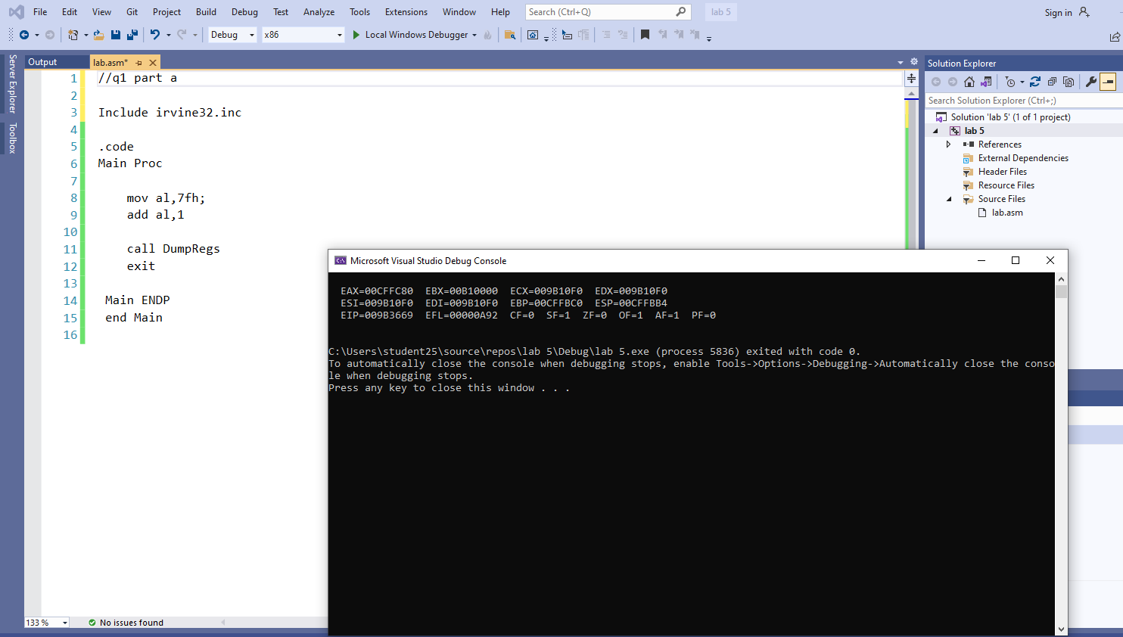

Code:;
;q1 part a

Include irvine32.inc

.code
Main Proc

mov al,7fh;
add al,1;

call DumpRegs
exit

Main ENDP
end Main

Q1 PART B).
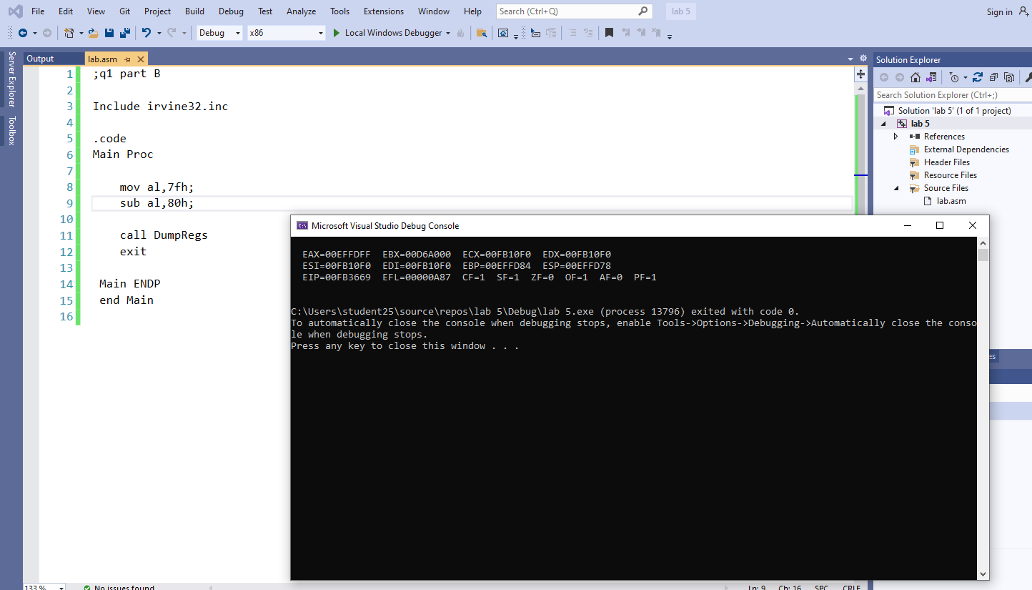

Code:
;q1 part B

Include irvine32.inc

.code
Main Proc

mov al,7fh;
sub al,80h;

call DumpRegs
exit

Main ENDP
end Main

Task#2).
a).
output:
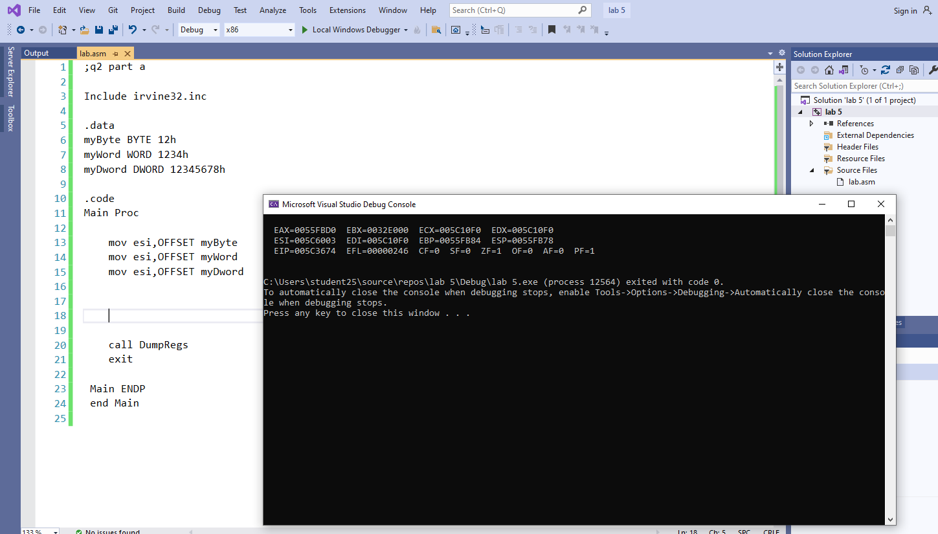
code:
;q2 part a

Include irvine32.inc

.data
myByte BYTE 12h
myWord WORD 1234h
myDword DWORD 12345678h

.code
Main Proc

mov esi,OFFSET myByte
mov esi,OFFSET myWord
mov esi,OFFSET myDword

call DumpRegs
exit

Main ENDP
end Main

b).
output:
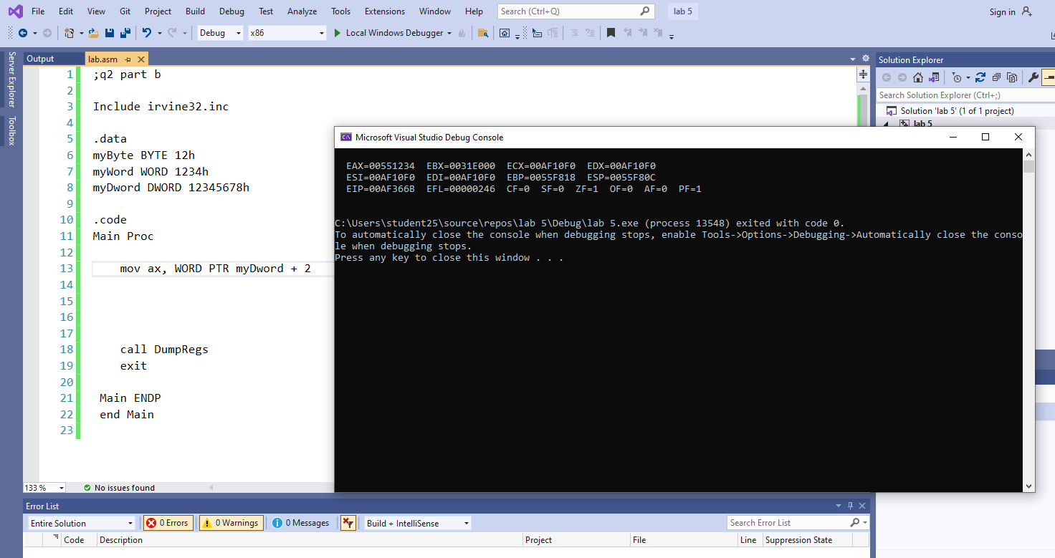

code:
;q2 part b

Include irvine32.inc

.data
myByte BYTE 12h
myWord WORD 1234h
myDword DWORD 12345678h

.code
Main Proc

mov ax, WORD PTR myDword + 2

call DumpRegs
exit

Main ENDP
end Main

c).
output:
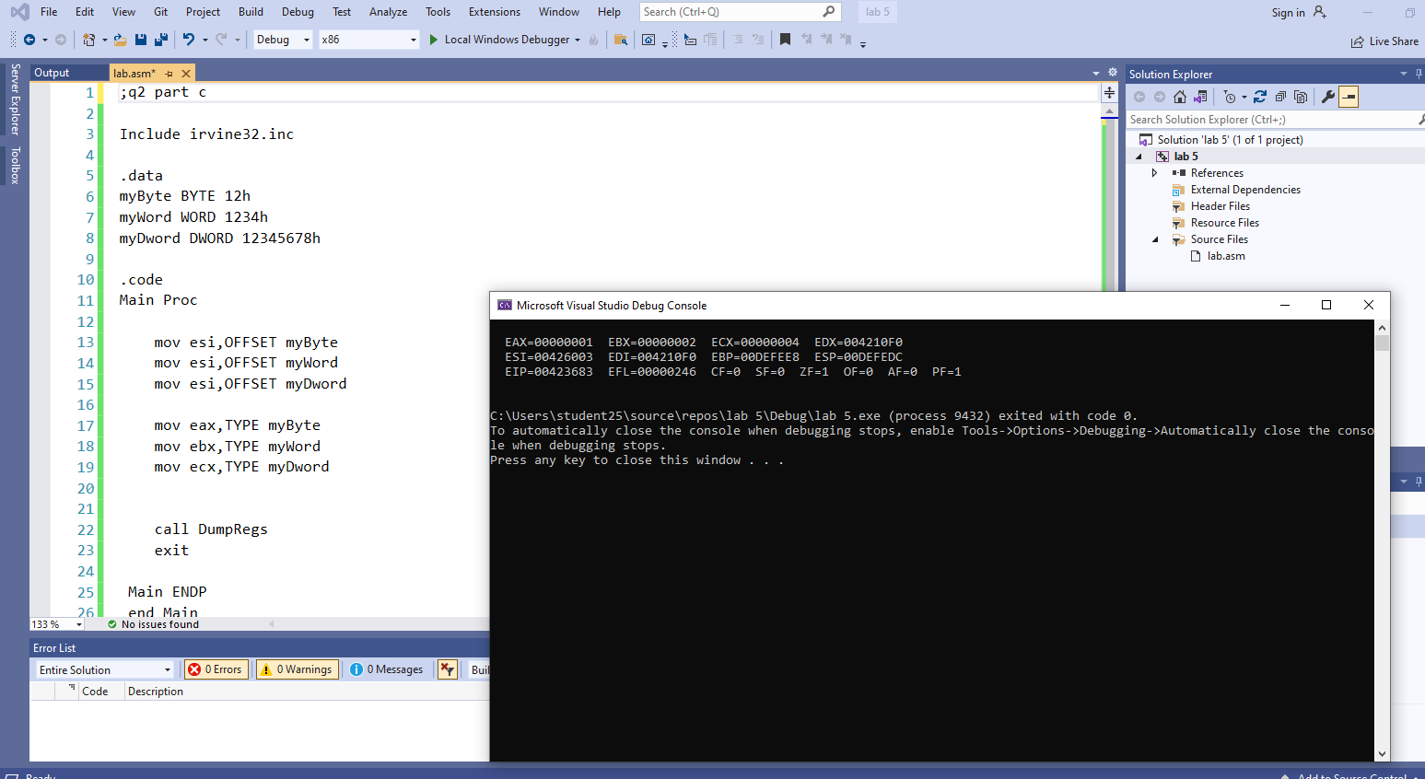
code:
;q2 part c

Include irvine32.inc

.data
myByte BYTE 12h
myWord WORD 1234h
myDword DWORD 12345678h

.code
Main Proc

mov esi,OFFSET myByte
mov esi,OFFSET myWord
mov esi,OFFSET myDword

mov eax,TYPE myByte
mov ebx,TYPE myWord
mov ecx,TYPE myDword

call DumpRegs
exit

Main ENDP
end Main

TASK#3).
A).
OUTPUT:
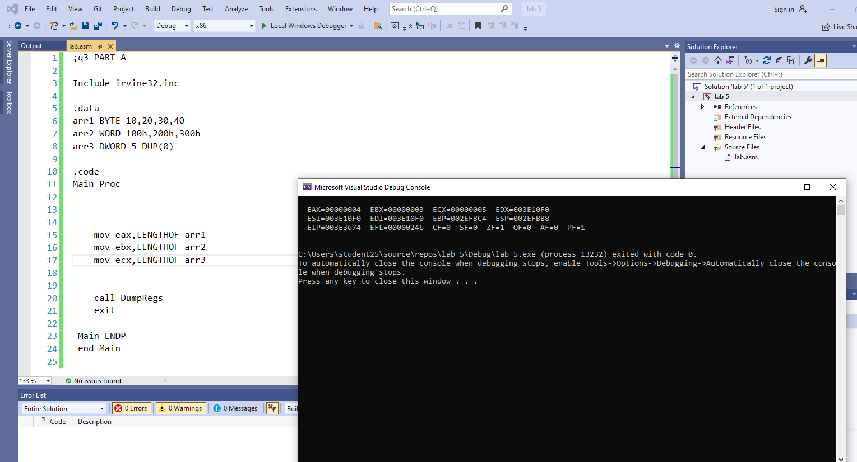

CODE:
;q3 PART A

Include irvine32.inc

.data
arr1 BYTE 10,20,30,40
arr2 WORD 100h,200h,300h
arr3 DWORD 5 DUP(0)

.code
Main Proc

mov eax,LENGTHOF arr1
mov ebx,LENGTHOF arr2
mov ecx,LENGTHOF arr3

call DumpRegs
exit

Main ENDP
end Main

B).
OUTPUT:
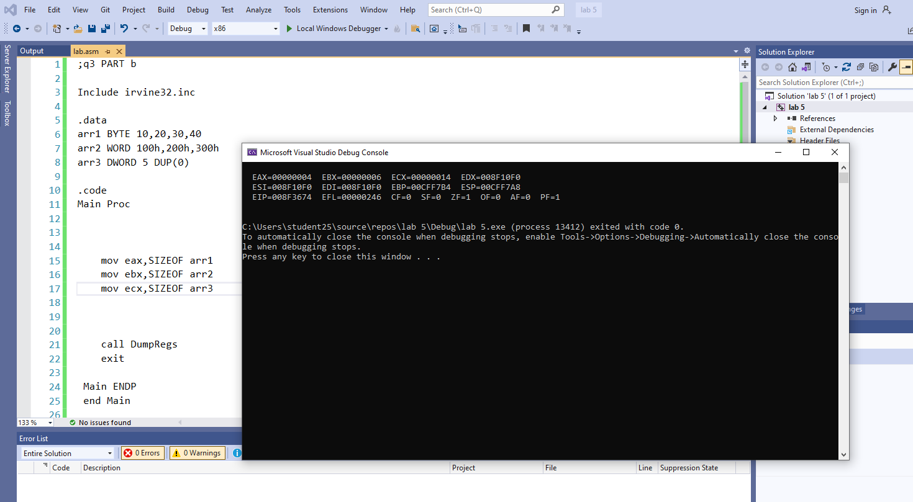

CODE:
;q3 PART b

Include irvine32.inc

.data
arr1 BYTE 10,20,30,40
arr2 WORD 100h,200h,300h
arr3 DWORD 5 DUP(0)

.code
Main Proc

mov eax,SIZEOF arr1
mov ebx,SIZEOF arr2
mov ecx,SIZEOF arr3

call DumpRegs
exit

Main ENDP
end Main

C).
OUTPUT:
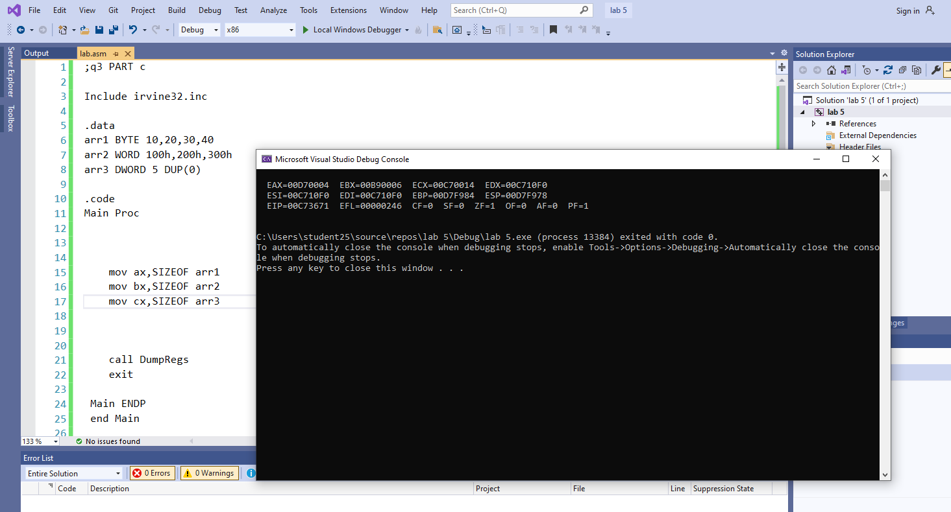

CODE:
;q3 PART c

Include irvine32.inc

.data
arr1 BYTE 10,20,30,40
arr2 WORD 100h,200h,300h
arr3 DWORD 5 DUP(0)

.code
Main Proc

mov ax,SIZEOF arr1
mov bx,SIZEOF arr2
mov cx,SIZEOF arr3

call DumpRegs
exit

Main ENDP
end Main

TASK#4).
A).
CODE:
;q4 PART A

Include irvine32.inc

.data
arrayB BYTE 11h,22h,33h
arrayW WORD 4444h, 5555h,6666h

.code
Main Proc

mov esi,OFFSET arrayB
mov al,[esi]
inc esi

mov bl,[esi]
inc esi

mov cl,[esi]
inc esi

call DumpRegs
exit

Main ENDP
end Main

OUTPUT:
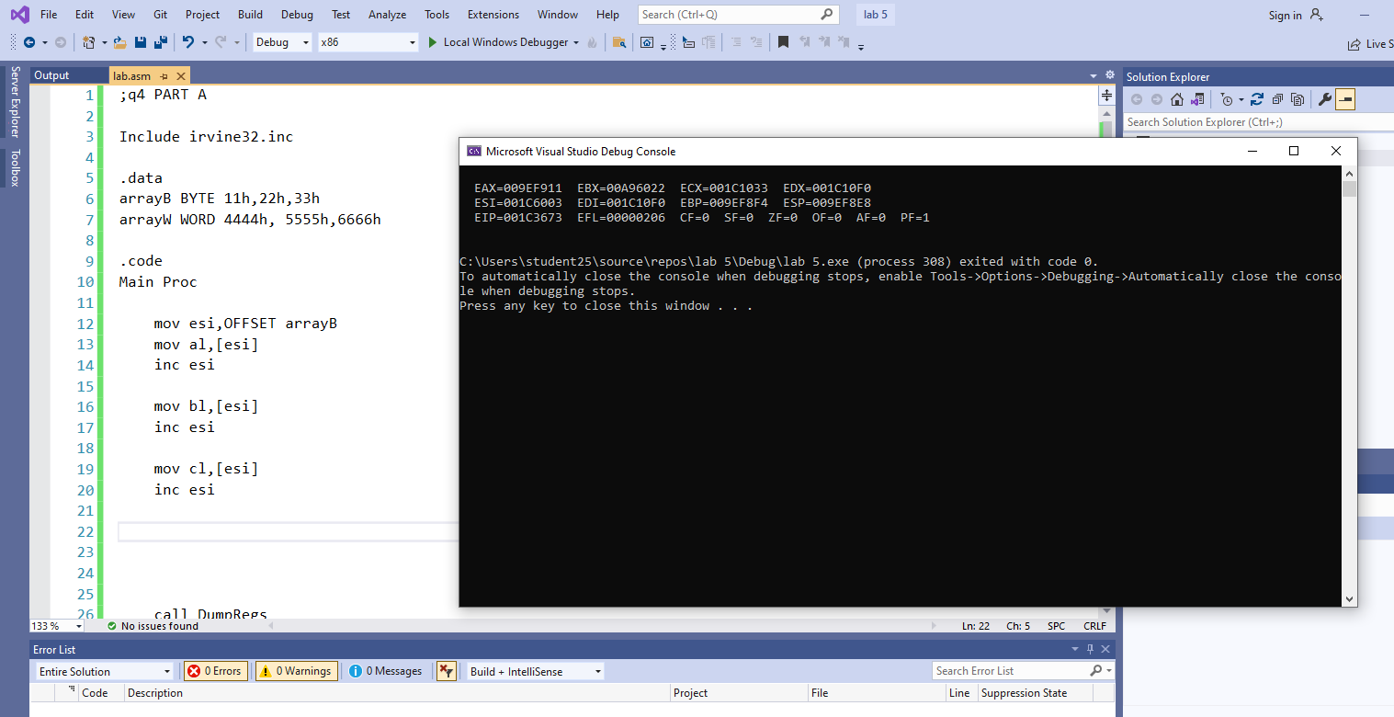

B).

CODE:

;q4 PART b

Include irvine32.inc

.data
arrayB BYTE 11h,22h,33h
arrayW WORD 4444h, 5555h,6666h

.code
Main Proc

mov esi,OFFSET arrayW
mov ax,[esi]
add esi,2

mov bx,[esi]
add esi,2

mov cx,[esi]
add esi,2

call DumpRegs
exit

Main ENDP
end Main

OUTPUT:
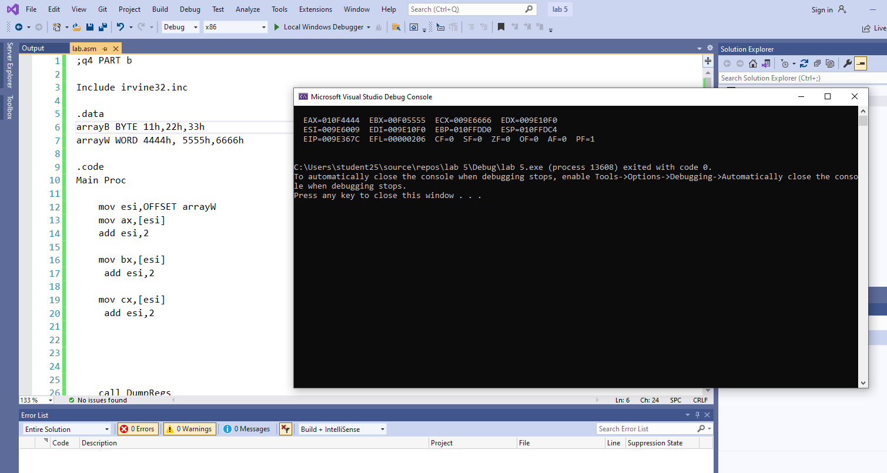

C).
Explanation : AS increment depends on the esi size of array element. For byte array it is just 1 increment and for WORD it increments 2 as esi only holds data of a byte address.

TASK#5).
A).
CODE:
;q5 part a

Include irvine32.inc

.data
arrayD DWORD 1000h,2000h,3000h,4000h

.code
Main Proc

mov eax,[arrayD + 1 * TYPE arrayD]

call DumpRegs
exit

Main ENDP
end Main
OUTPUT:
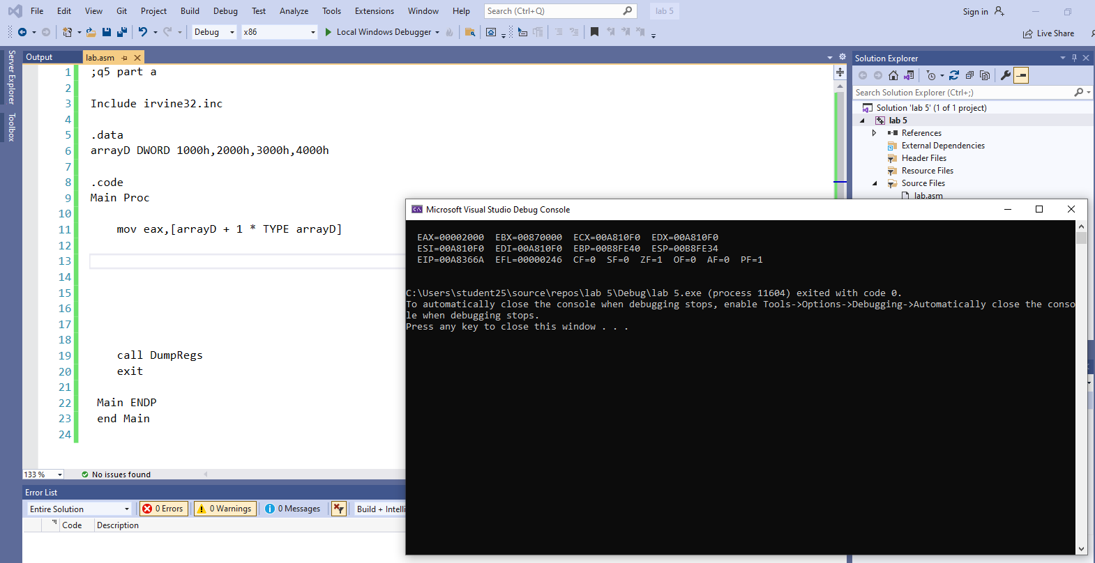

B).
CODE:
;q5 part B

Include irvine32.inc

.data
arrayD DWORD 1000h,2000h,3000h,4000h

.code
Main Proc

mov ebx,[arrayD + 3 * TYPE arrayD]

call DumpRegs
exit

Main ENDP
end Main

OUTPUT:
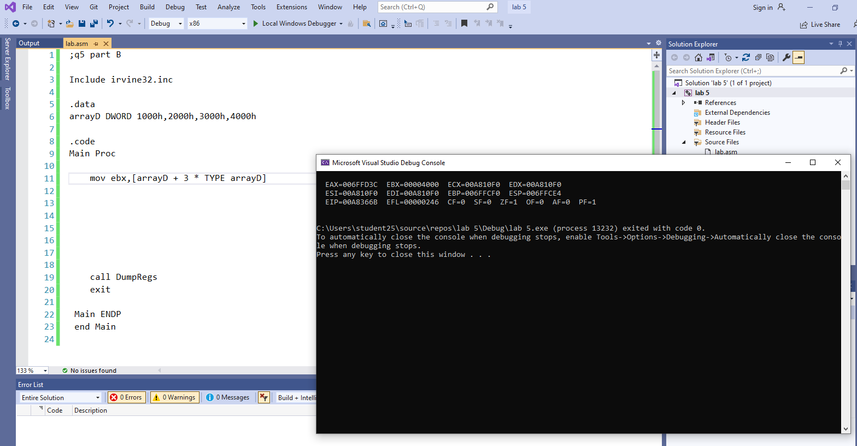

C).
EXPLANATION :
Type of operator purpose is used to tell the size that each element has taken like in bytes,words etc.so it just return bytes for the variable for all elements of the array.

